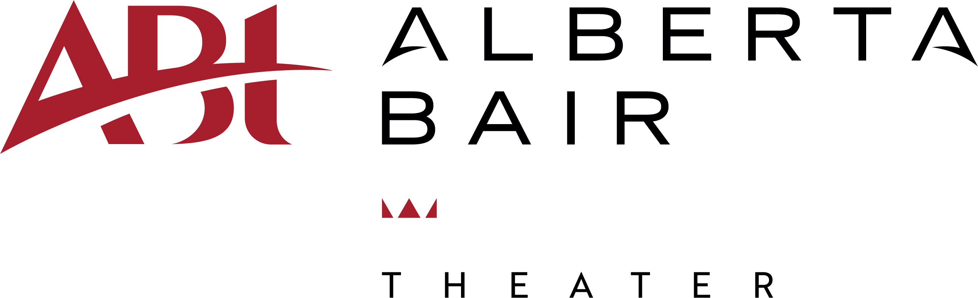

JOB DESCRIPTION

Title: Production Manager
Hours: Varies – Includes evenings, weekends and holidays as needed
Part Time: Non-exempt; hourly
Reports To: Technical Director

SUMMARY

Alberta Bair Theater is seeking a Production Manager to assist the Technical Director with production advancement in our newly remodeled 1,394 Capacity Roadhouse Theater.

This position is responsible for:
- Assist Tech Director (TD) and Assistant Tech Director (ATD) in production details, planning and execution.
- Create a production timeline. Schedule all production needs.
- Effectively communicate and coordinate with performers and/or their representatives, crew members and staff for all event production.
- Attend staff and production meetings.
- Obtain, organize, and review all production documents, including Technical Riders, Hospitality Riders, and Front of House Riders.
- Maintain organization of stage, backstage area, and theater.
- Troubleshoot faulty equipment.
- Update lobby and live show monitors.
- When needed, assist TD & ATD with stage management, circuiting, patching, programming events, Lighting Director, and Spotlight Operator.
- Work with the TD & ATD to identify opportunities for theater/production improvement.

Professional Required Experience:
Stage operations with knowledge of theatrical staging, rigging, audio, lighting, and current safety regulations and practices.

Skills Required/Ability to:
- Communicate successfully with the diverse roadhouse industry and staff, maintaining a calm and energetic work environment amid deadlines.
- Organization, Critical Thinking, Problem Solving, Time Management, and Leadership.
- Operate ETC lighting control boards and accomplish stage and lighting designs.

Basic Job Requirements:
- Maintain communications with TD & ATD and other departments.
- Work each event in an appropriate role within varying roles and assist wherever needed.
- Competent computer and communication skills.
- Strong organizational skills.
- Knowledge of and adherence to “safety first” procedures.
- Ability to:
- Climb ladders.
- Lift and carry up to 50 pounds.
- Stand for long periods of time.
- See and hear activities on stage from any point in the seating area.

Success in this position will allow the right applicant to effectively lay the groundwork for an outstanding production while organizing the technical team to provide a measurable highly satisfactory customer experience to promoters and artists.

To apply, send a letter of interest and resume by June 9, 2023 to; Tim Kiser, Technical Director, at tkiser@albertabairtheater.org

